VSCode Feature Documentation

# Feature One: Debugger

The debugger is a useful tool in VSCode that allows you to run your code from inside the application. It can help find errors quickly without the need to open a command prompt tab, put your file directory, then put in the command to run the file, then finally test it. With this, it’s much more convenient to actually just do it then and there. In order to actually use this debugger, follow the following steps. First, navigate to your VSCode tab.

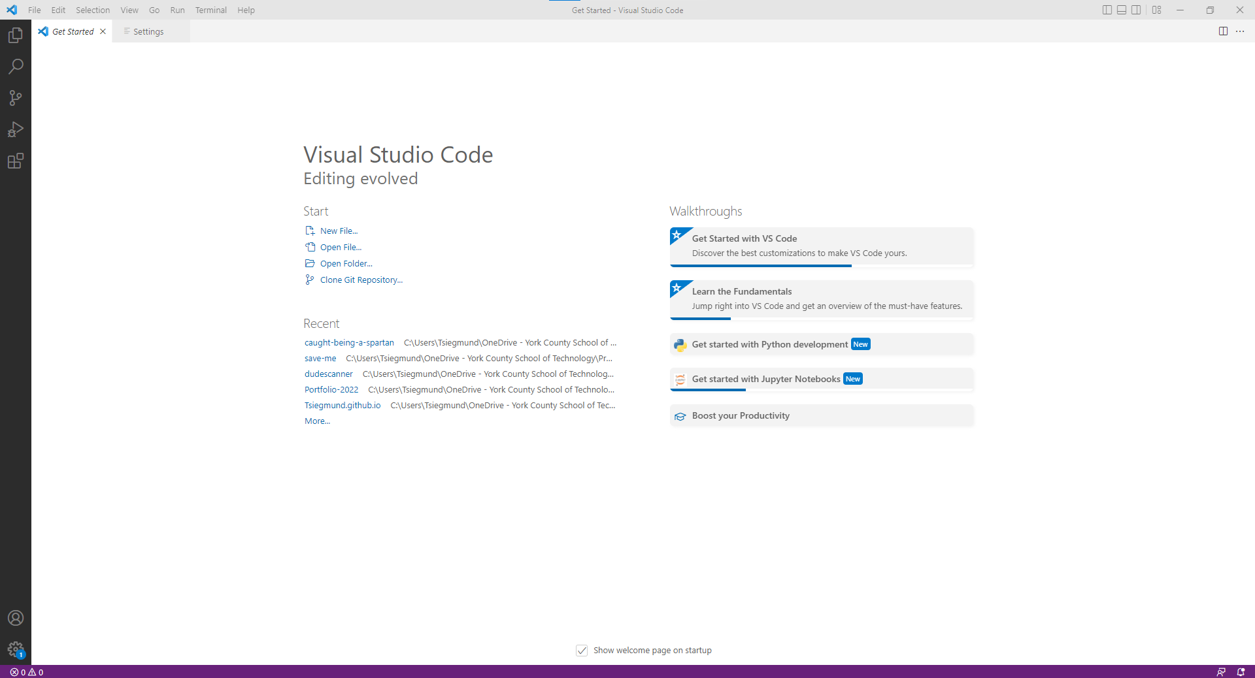

Once in your VSCode tab, you now need to open your file. Go to the top left and click the “file” tab. Once there, you can either open a single file or a whole folder. For this, I’ll be opening a folder. After you click “Open Folder.” Go to the folder you wish and work with and click “Select Folder.”

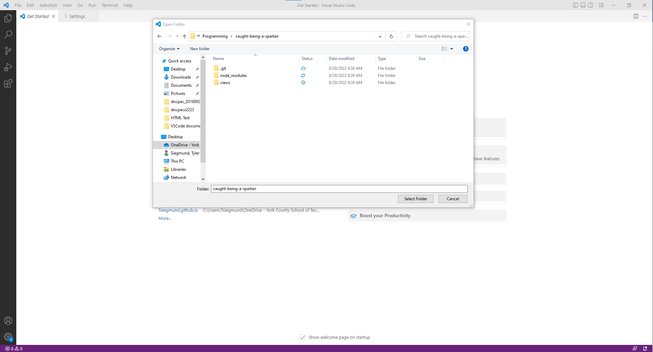

Now that you are in your folder, you can type up any code you want. Our code will be one that will make a basic HTML page. Once you got all your code typed up, you obviously need to test to make sure it works. So, first thing you need to do is go back to the tabs in the top left. Navigate to the Run tab. Once there, go to Start Debugging. This will open a small terminal at the bottom that can show errors.

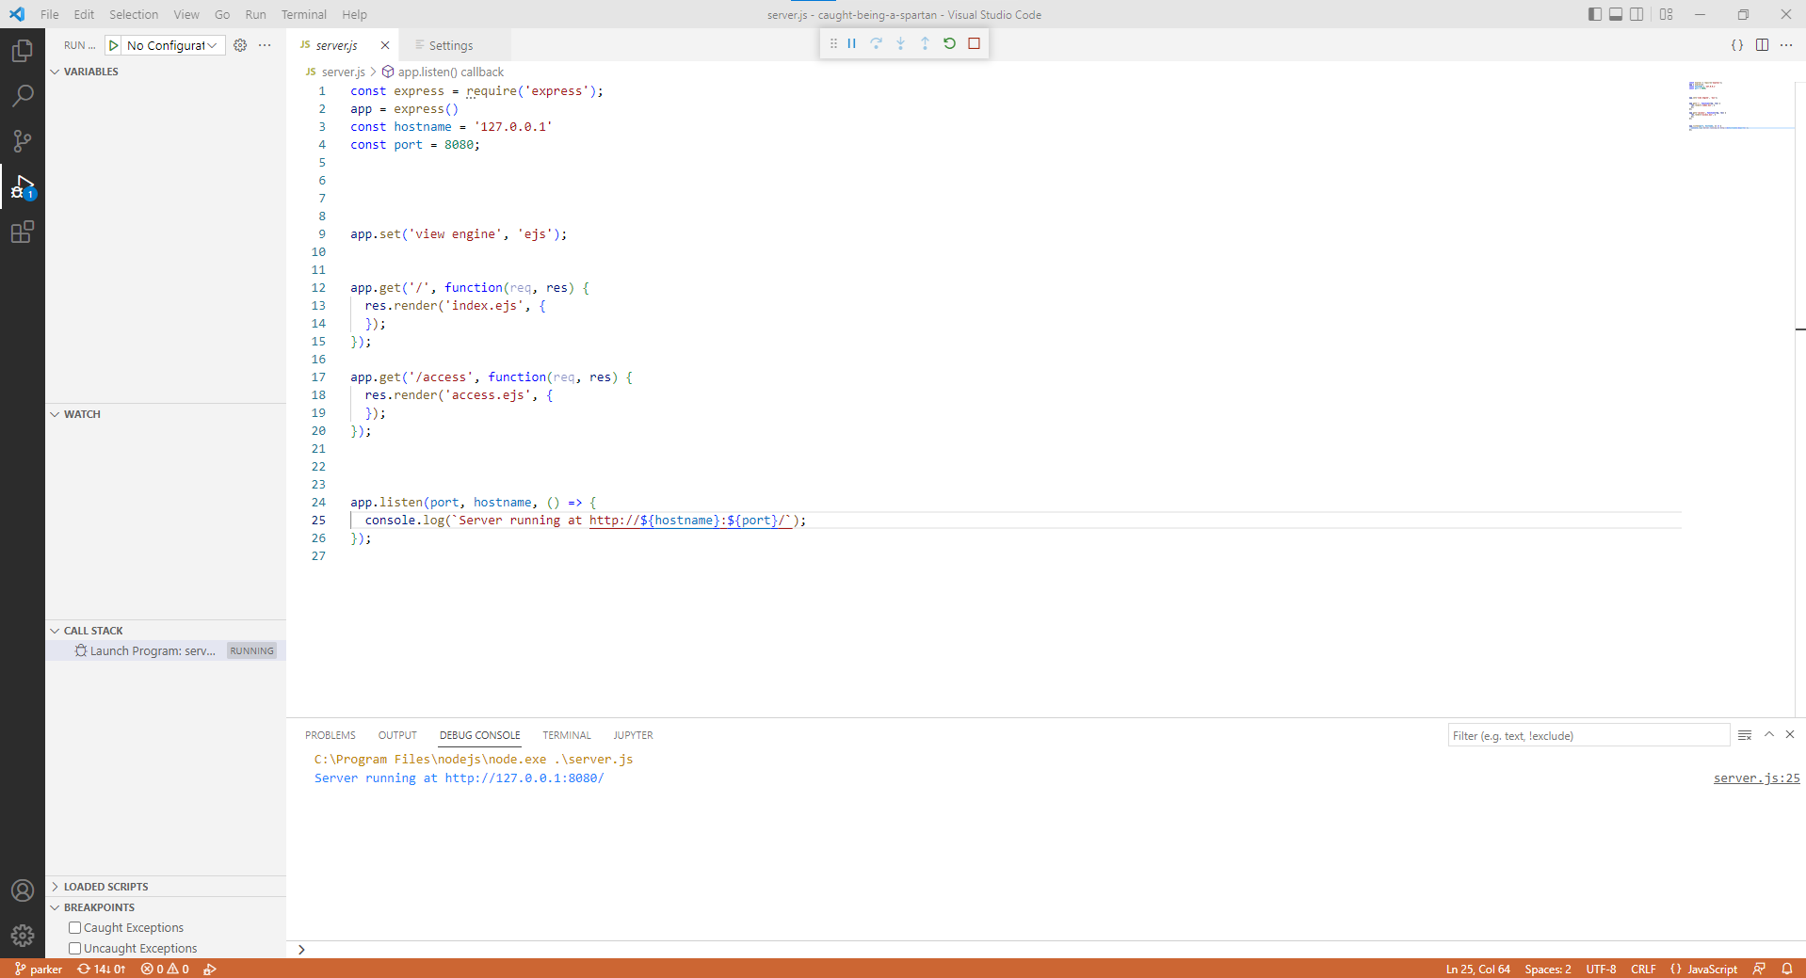

At the bottom, you have the debugger. For me, it’s showing a small message saying a console.log message I sent using the code. With this running, I could go to the URL mentioned in the console. If there is an error, it would post the error in the debugger as well as where the error was (EX: Syntax error, line 59)

# Feature Two: Plugins

VS code has many little plugins that can each do something unique. Ranging from allowing you to debug python code to Node.js snippets that allow you to do more with simple things by just typing smaller, more simple messages. In order to actually get any plugins, you’ll firstly need to actually get to where you get plugins. There are two ways. Either go down to the cog in the bottom left of the screen, or simply just press CTRL + SHIFT + X. If done correctly, you should be able to see this on the left side of your screen.

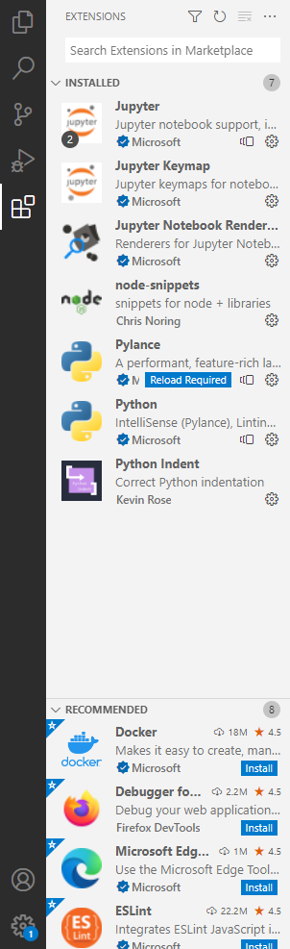

The following screen has a few plugins that I installed from the library. I have python ones and a node one. For this, we’ll use the example with node-snippets. Now obviously, you could always look at the recommended, but if you want to find any specific plugins, you’ll need to use the search bar. This is just above our installed tab. Once you see a little bar that reads “Search Extensions in Marketplace.” Now, we’ll need the node-snippets plugin. So, go to that little bar we mentioned before and type “node-snippets” in it. For this specific one, you’ll see these two.

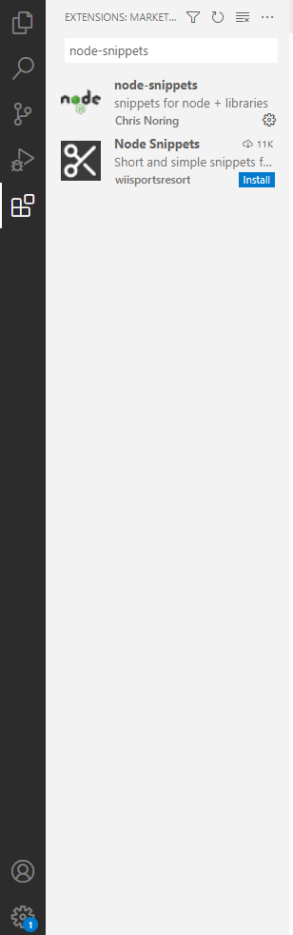

Click whichever one you want. I’ll be clicking the one from Chris Noring. You click on it and it’ll bring up a page with details about the plugin. Read this and determine if this is what you want. If you decide that the plugin is what you want, click install. The image below will show an example of what you’ll see.

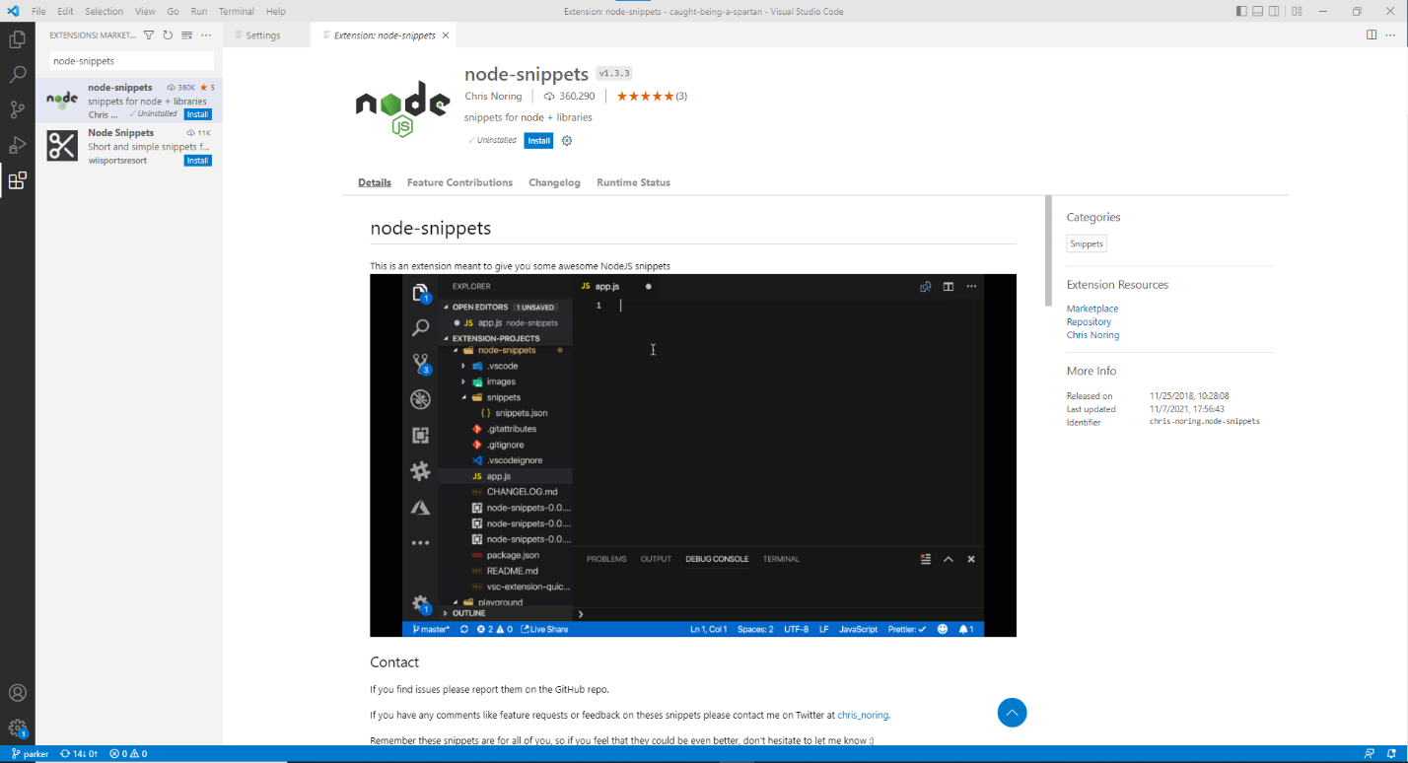

Once you clicked install, you’ll have your plugin! This node-snippets plugin is extremely useful. I highly recommend it because you have to type much less to still get the lines of code you need.

# Feature Three: Settings Sync

Settings sync is a feature that allows the user to have the settings they choose in VSCode to sync across all platforms that you use. This can be useful if you work on VSCode using multiple devices and would find It more convenient to just use one set of settings across many devices than to use a different set of settings on each device. In order to turn on settings sync, you’ll need to go to your settings in the bottom left corner. Once there, you’ll see a screen similar to this.

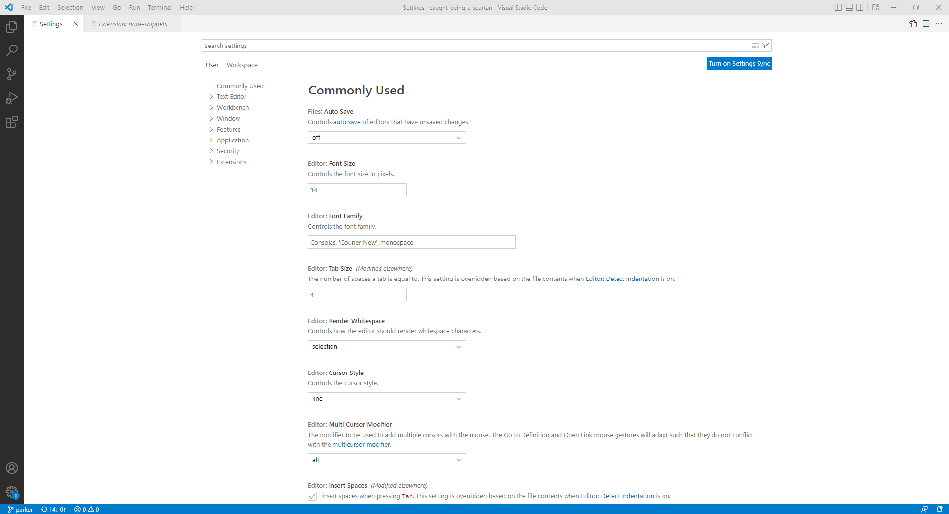

Upon observing this screen, you may notice the settings sync button in the slight top right. If not, I circled it just in case.

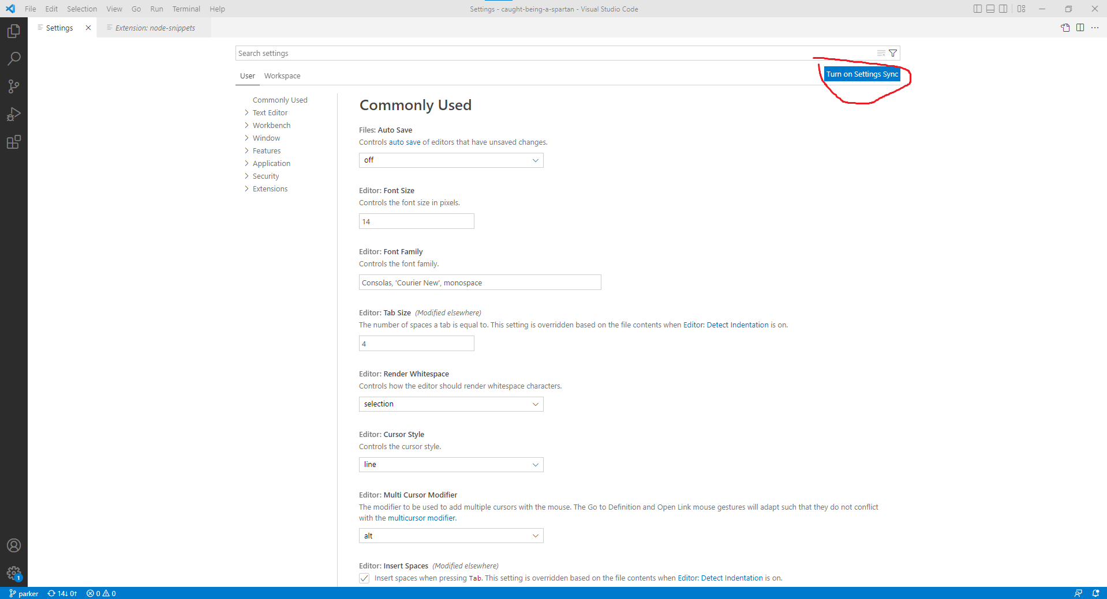

Once you click on it, you’ll see that you need to pick what you want to transfer over what you wish. I will provide a screenshot of what you’ll see when you click on it.

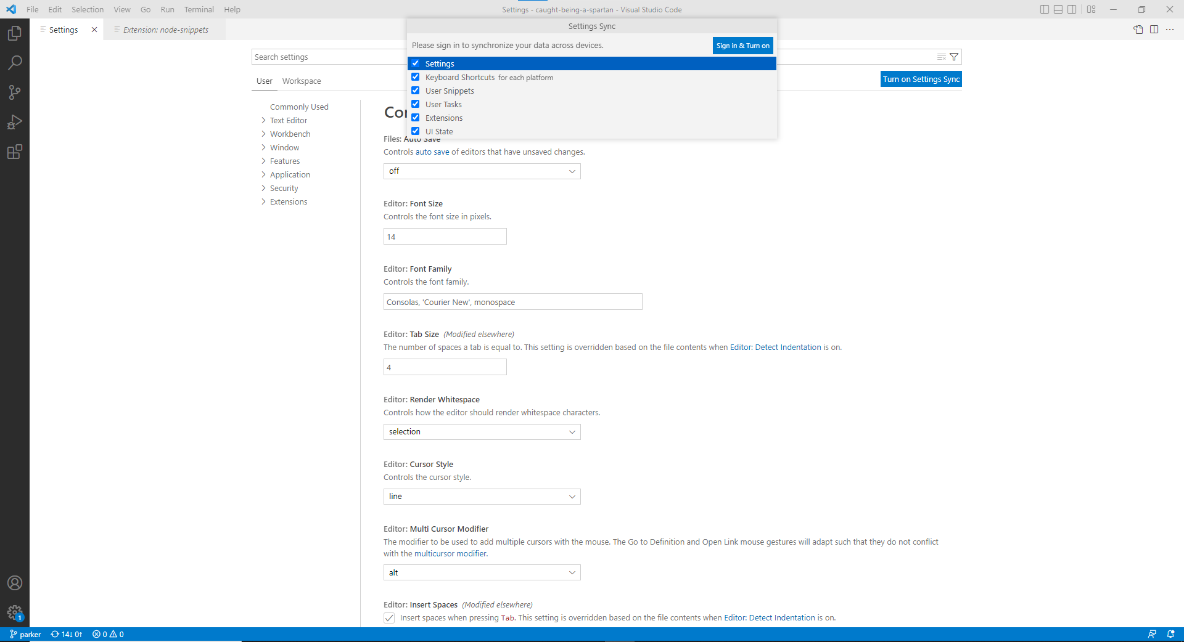

Once you get here, decide what you do and don’t want. After that, click “Sign in and Turn On.” You’ll be prompted to sign in with either Microsoft or Github. I’ll choose github for this.

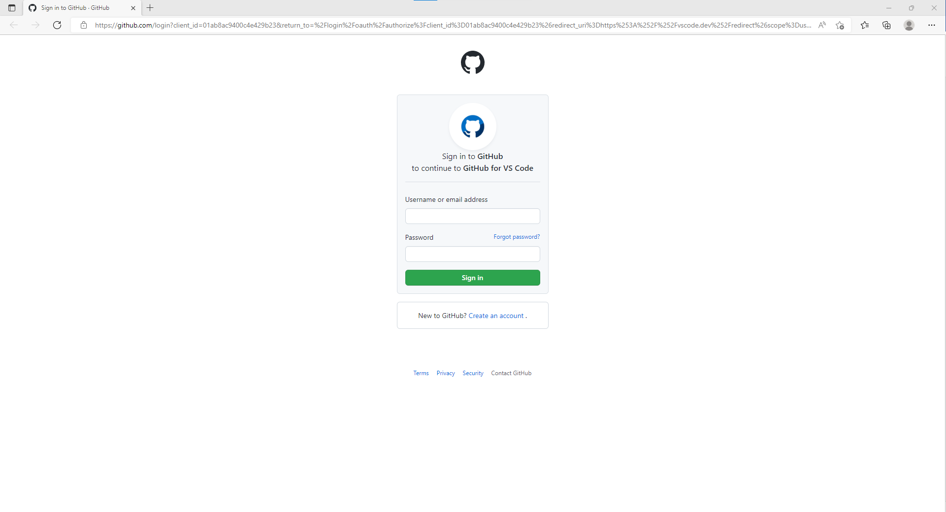

Sign into whatever you want, then authorize whatever you’re using to connect data. After all that, go back to VSCode and see anything it’s telling you to do. Once you finish, you’ll have your settings synced once you sign in on other devices! Now you can have your settings match your other devices.